Project Design Phase-II
Data Flow Diagram & User Stories

Date | 29 september 2026
Team ID | 6ab3db0c6603573ccfb381c9
Project Name | AI WeatherWise
Maximum Marks | 4 Marks

Data Flow Diagrams:
A Data Flow Diagram (DFD) is a graphical representation of the flow of data within the AI WeatherWise system. It shows how weather information is received, processed, stored, and presented to users. The DFD represents the interaction between the user, weather data source, AI processing module, database, and the weather application. It helps to understand how current weather data, forecasts, weather details, AI-based insights, and alerts flow through the system.
The AI WeatherWise DFD shows how users enter a location or request weather information, how the system collects weather data, processes it using AI techniques, and provides accurate and easy-to-understand weather forecasts and insights to the user.
Example: DFD Level 0 (Industry Standard)
Example: (Simplified)
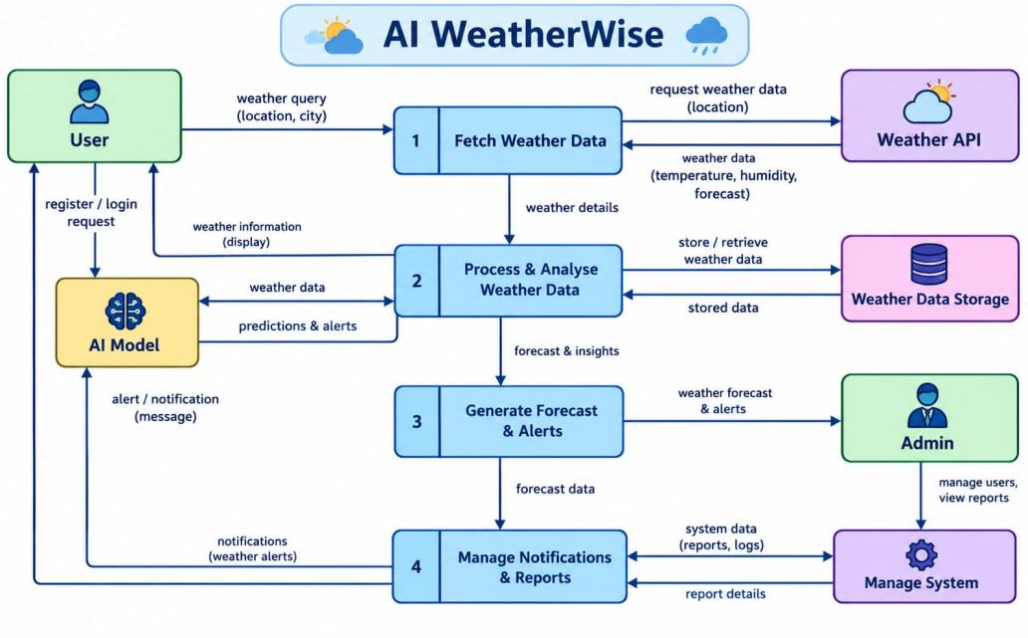

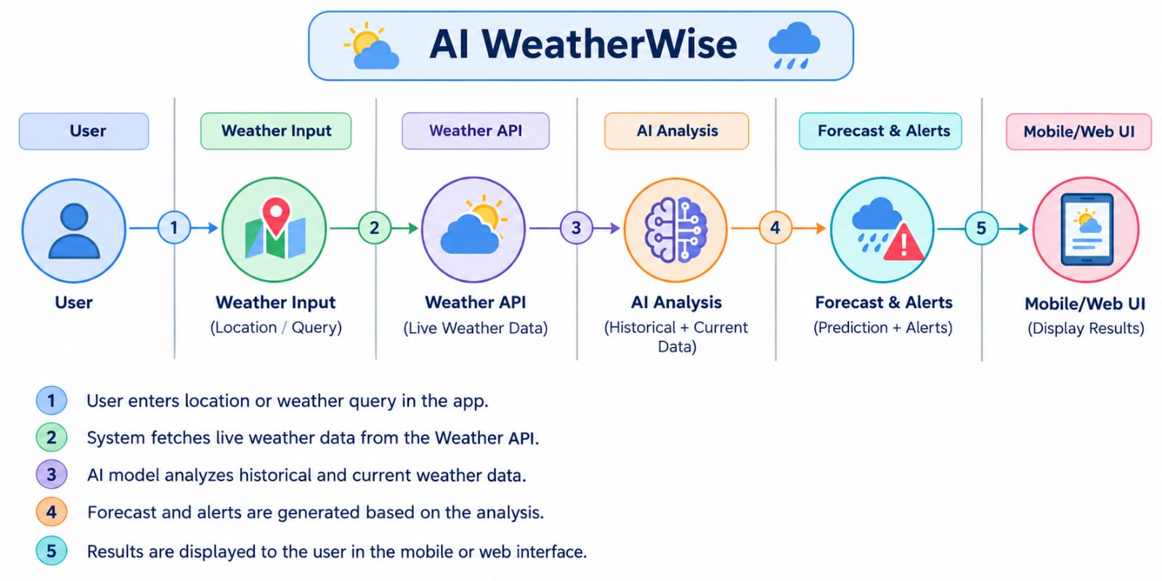
User Stories
Use the below template to list all the user stories for the product.
User Type | Functional Requirement (Epic) | User Story Number | User Story / Task | Acceptance criteria | Priority | Release
Customer (Mobile user) | Registration | USN-1 |  | I can access my account / dashboard | High | Sprint-1
 |  | USN-2 | As a user, I can receive confirmation after successful registration. | I can receive confirmation email & click confirm | High | Sprint-1
 |  | USN-3 | As a user, I can log into AI WeatherWise | I can register & access the dashboard with Facebook Login | Low | Sprint-2
 |  | USN-4 | As a user, I can receive an error message when incorrect login details are entered. |  | Medium | Sprint-1
 | Login | USN-5 | As a user, I can search for weather information by entering a city or location. |  | High | Sprint-1
 | Dashboard
Customer (Web user)
Customer Care Executive
Administrator

